Case Text

1. **IMAGE:** HIGH RESOLUTON JPEG or TIFF. Minimum 300 dpi. Email to SoG.

2. **TEXT:** 850-1100 characters incl. spaces

3. **COURTESY:** List the companies/organisations who contributed to the case

**Example: Case-layout and text:**

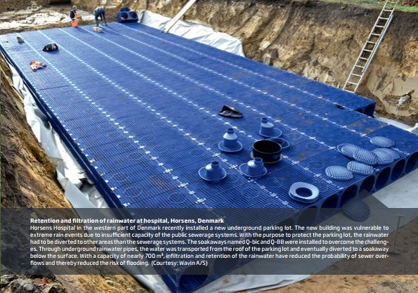

**3.5.**



**2.5.**



**1.**



Case text

|  |
| --- |
| 1. IMAGE: HIGH RESOLUTON JPEG or TIFF. Minimum 300 dpi. Email to SoG. |

|  |
| --- |
| 1. *CASE TEXT: 850-1100 characters incl. spaces*   Insert text… |

|  |
| --- |
| 1. *COURTESY: List the companies/organisations which have contributed to the case*   Insert text… |
| 1. *Contact person* |

Notice:

* Casen text is preferred in a Latin American context.
* Please attach min. 2 pictures in TIFF or JPEG format (min 300 dpi)

Case content should include:

1. The challenge.
2. The solution and e.g. barriers.
3. Description of value creation (How and for whom value was created?) - preferably with financial figures (payback time for investment or similar) and / or achieved energy savings.

Forward case and pictures to Emil Stub, [emns@di.dk](mailto:emns@di.dk)